**Please use this form to complete your report. You can delete the text that describes each section, and replace the figures with your own graphs and pictures!   
(Don’t worry, any unused figures will be ignored)**

Team Name: Trentini DOP

Chosen theme: Life in space

Team members: Matteo Nardin, Lorenzo Berlanda, Mattia Tomasi, Stefano Libardi

School**:** CoderDojo Trento

# Introduction

The purpose of the experiment proposed by our group is the analysis of environmental parameters within the International Space Station, with particular attention to their performance during the 3 hours long observation and their variations according to the position of the ISS (exposure to the Sun or "nocturnal" flight).

From the analysis of the collected data, we expect to observe a substantial stability of the parameters of temperature, pressure and humidity. That is because the ISS is naturally equipped with components aimed at maintaining optimal values for the safety of the crew and for the normal course of operations and life on board: the PTCS (Passive Thermal Control System) and the EATCS (External Active Thermal Control System) have just this task.

However we expect to observe some small oscillations with respect to the nominal values (about 24.8°C for the temperature and 101.3 kPa for the pressure). For us terrestrials, the variability of these parameters means only a sweat or a runny nose, but in space it's a matter of life or death!

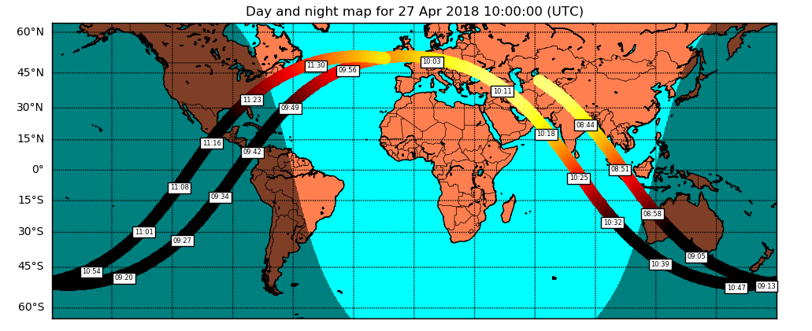

**Figure 1: During the 3 hours long experiment the ISS completed nearly two orbits.**

# Method

The data were obtained thanks to a program in Python in which a dedicated thread continued - at a very high frequency - to consult all the parameters provided by the Sense HAT installed on Ed: in this way the slow sensor initialization phenomena were limited and in particular the gyroscope module was able to perform reliable calculations. These measurements were sampled with a frequency of one second and every 20 seconds were “flushed” in a CSV file on the disk. All data are accompanied by a timestamp. The data collected were imported into a spreadsheet and for a first analysis the graphs of all the parameter families were prepared:

1) the temperature collected by the SenseHAT and the CPU temperature of the Rasperry Pi;

2) the pressure at the inside the spatial modul;

3) the ambient humidity;

4) the three components of the accelerometer;

5) those of the gyroscope;

6) those of the magnetometer (Fig. 2).

The most detailed graphic and mathematical analyses were carried out with Matplotlib and SciPy, whereas reconstruction of the ISS orbit and georeferenced graphs thanks to PyEphem and BaseMap.

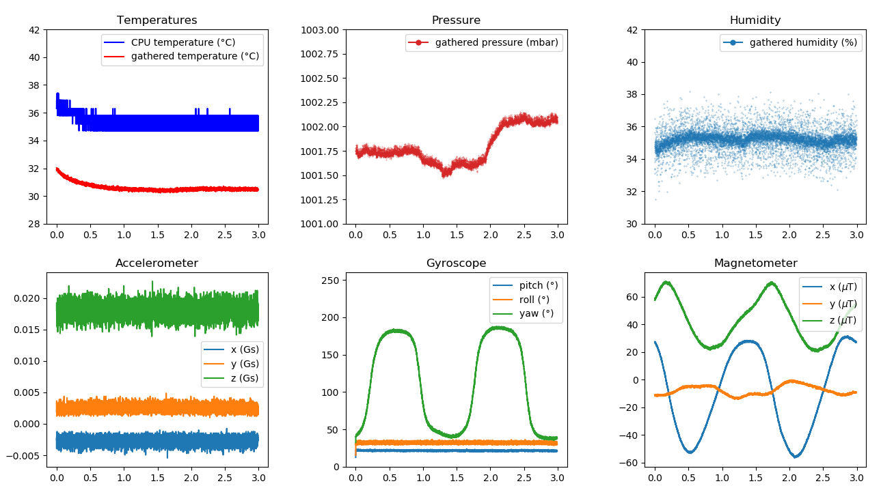

**Figure 2: Overview of the data collected during the 3 hours of experiment**

# Results

At a first qualitative analysis of the environmental parameters connected to the atmosphere inside the ISS, we can say that the humidity graph indicates a substantial stability of that parameter around 35% (third graph of Figure 2). The pressure, on the contrary, shows some changes of a few tenths of millibars, which seem to remain quite stable for a dozen of minutes (according to the graph in Figure 2): the behavior does not show a clear trend and we wonder if these changes can be traced back to normal activities of the crew such as the opening or closing of compartments, the air recirculation system or perhaps the use of the toilet by the crew.

Our experiment took place from 08:36 to 11:36 (GMT) on 2018-04-27 and we suppose that it was a normal Friday morning working.

The temperature graph (first graph of Fig. 2) shows an interesting non-constant trend, so we focused on that. We clearly notice a descending curve of the typical temperature of a body that cools (from 32 to 30.5 ° C) . We think that it is not due to an environmental factor but to a momentary overheating of the Rasperry Pi: maybe the AstroPi team that turned the experiment before our submitted the CPU to high stress, while the final 30.5 ° C seems the temperature of thermostatation with the laboratory.

We asked the mentors for help to better analyze the details hidden within this macroscopic trend and what we got is the graph of Figure 3. It seems that there is an oscillation with a period of an hour and a half! So we used PyEphem to reconstruct the moments of the shadows and those of exposure to the Sun, drawing the height of the Sun from the local terrestrial horizon and we reported everything in Figure 4. But, damn: they don’r look very in phase… See figure 5.

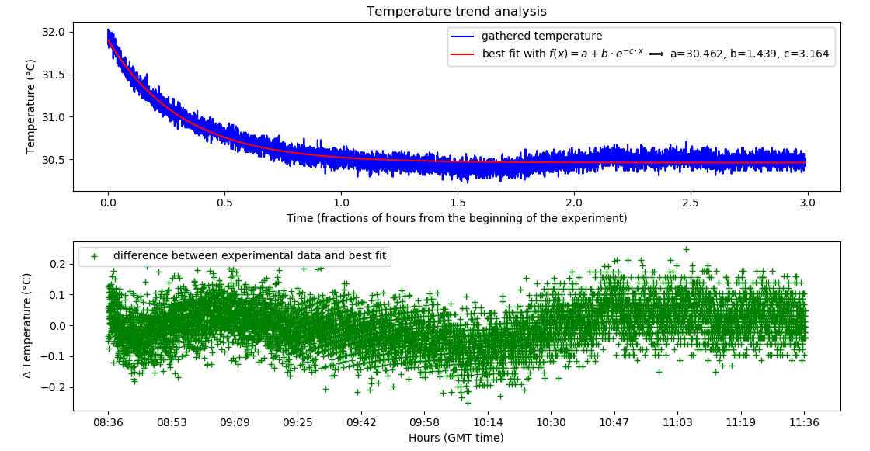

**Figure 3: Temperature trend analysis (a) and oscillations over the cooling curve (b)**

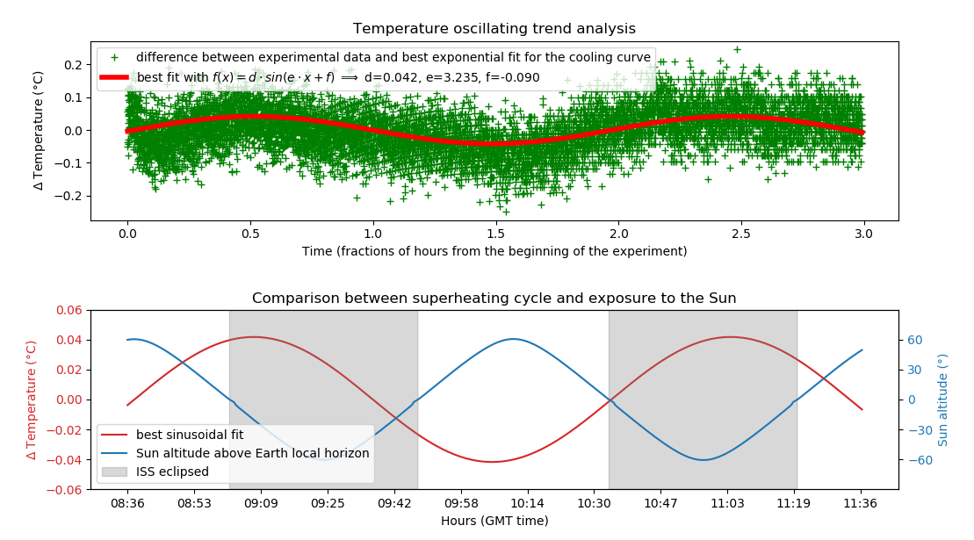

**Figure 4: Superheating cycle (a) and exposure to the Sun (b)**



**Figure 5: “Trentini DOP” team at work**

# Conclusion

The way in which the graph of the superheating and the one of the height of the Sun on the horizon intersect (graph b of Figure 4) surprised us a bit: we expected them to be synchronized, and instead seem completely out of phase.

In fact, it is right to expect a phase shift, because the ISS should warm up (graph of increasing temperature) when it is exposed to the Sun: we have highlighted this time frame, shading the moments when the ISS is eclipsed. Even considering this, the graphs still appear very out of phase! It seems that the delay between the start of the heating and the exposure, and between the start of cooling and entry into the shadow zone is about 20 minutes.

In order to validate our reasoning, we asked to our friends of the "Team Lampone" for help and got their data on loan: we reported them in the last graph (figure 6) and in this case the agreement is very good, given that the temperature curve seems to grow right at intervals where the ISS is not eclipsed.

We can not explain the reason for the phase delay in the measurements we have collected: perhaps artifacts were introduced during processing (the fit for the marked cooling trend) or perhaps Ed is located in a part of the laboratory where the thermal effects of the control system propagate more slowly than where is Izzy?

Who knows, we are still thinking about it (see Figure 5).

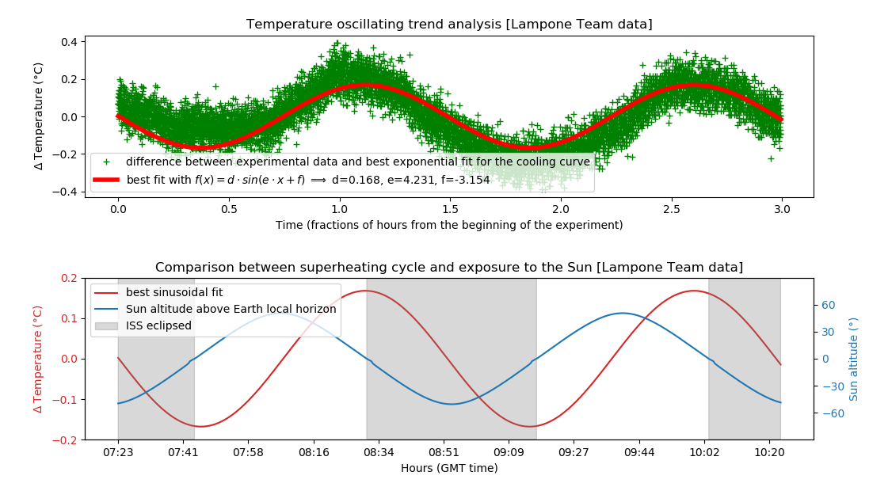

**Figure 6: Superheating cycle (a) and exposure to the Sun (b) for the “Lampone Team” data**